**Step 1**

* Click on **Create New**
* Type “**ERD**” into the search and select “Entity Relationship Diagram”

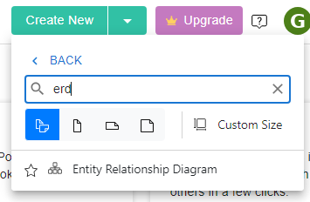

**Step 2**

* You only need one item for this diagram – the entity icon

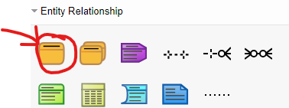

**Step 3**

* Click and drag an **Entity** onto your page
* Enter a name at the top
* Resize the Entity box to suit

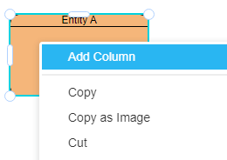**Step 4 – ADDING A NEW COLUMN**

* Right Click on the box and select **ADD COLUMN**

**Step 5 – ADDING A COLUMNS NAME + DATATYPE**

* Type in the **name of the column** – hit tab a couple of times then type in the **data type** and **size**

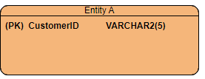

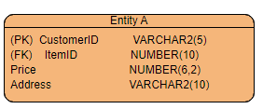

**Step 6 – ADDING REMAINING COLUMNS**

* Repeat this process as necessary

**Step 7 – ADDING PRIMARY and FOREIGN KEYS**

1. Type (PK) or (FK) into the column as necessary
2. Right click on the **primary key column** and select primary key (text will be bold)
3. Right click on the **foreign key column** and select foreign key (text will be italics)

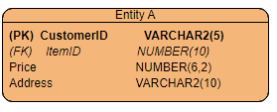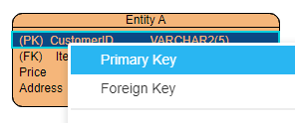

**Step 8 – DRAWING RELATIONSHIPS**

* Draw relationships from one entity to another and select **ONE to MANY option** only (paying attention to rules for the MANY end)

